**Basic Data Structures in Java Assignment**

Q1: Find out if the given number is an Armstrong number or not.

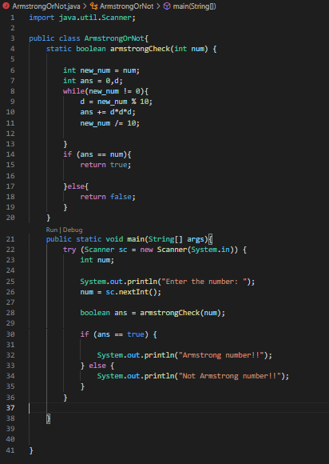

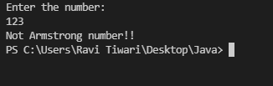

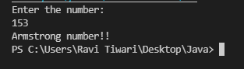

Q2. Find out all the Armstrong numbers falling in the range of 100-999



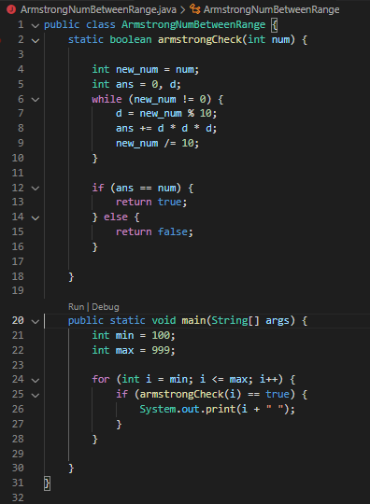

Q3. Find out the simple as well as the compound interest of supplied value

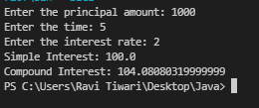

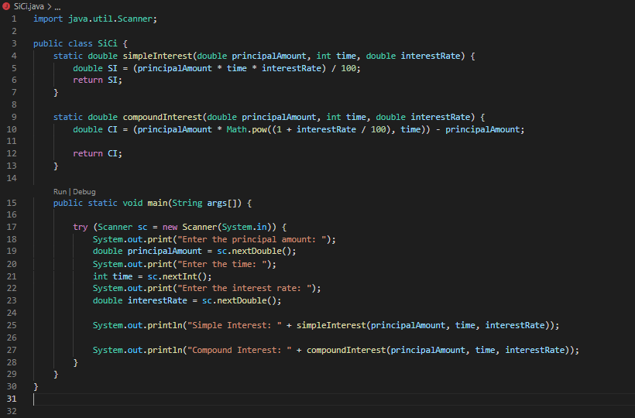

Q4. Supply marks of three subject and declare the result, result declaration is based on below conditions:

Condition 1: -All subjects marks is greater than 60 is Passed

Condition 2: -Any two subjects marks are greater than 60 is Promoted

Condition 3: -Any one subject mark is greater than 60 or all subjects’ marks less than 60 is failed.

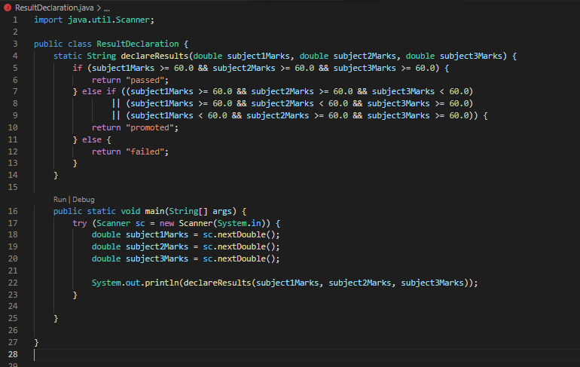

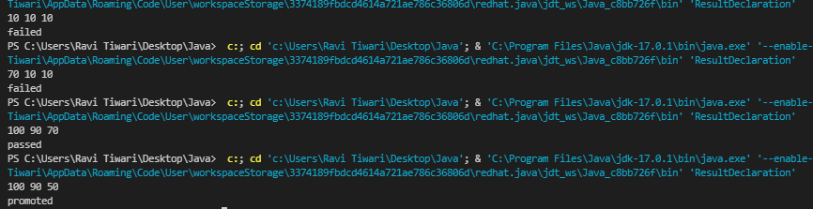

Q5. Calculate the income tax on the basis of following table.

Note:-Assume slab is consider for Male, Female as well as Senior citizen

Slab Income Range Tax payable in Percentage

Slab A 0-1,80,000 Nil

Slab B 1,81,001-3,00,000 10%

Slab C 3,00,001-5,00,000 20%

Slab D 5,00,001-10,00,000 30%

Accept CTC from user and display tax amount

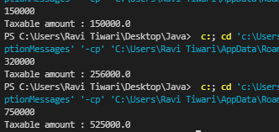

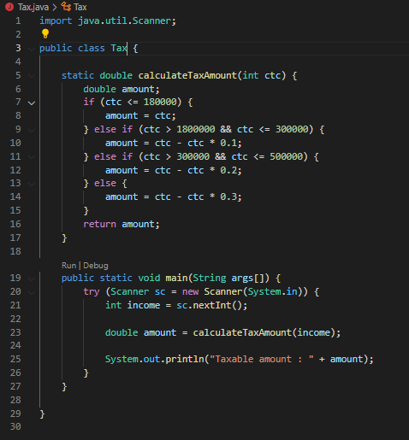

Q6. Consider a CUI based application, where you are asking a user to enter his Login name and password, after entering the valid user-id and password it will print the message “Welcome” along with user name. As per the validation is concerned, the program should keep a track of login attempts. After three attempts a message should be flashed saying “Contact Admin” and the program should terminate.

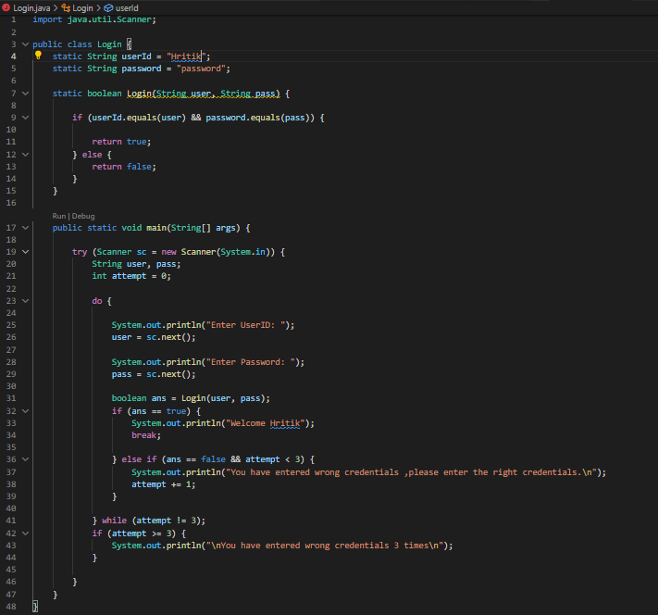

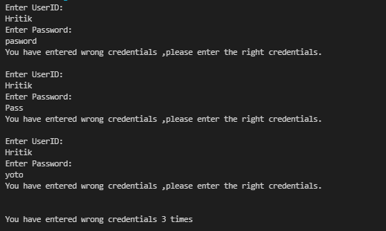

Q7. There is an Array which is of the size 15, which may or may not be sorted. You should write a program to accept a number and search if it in contained in the array

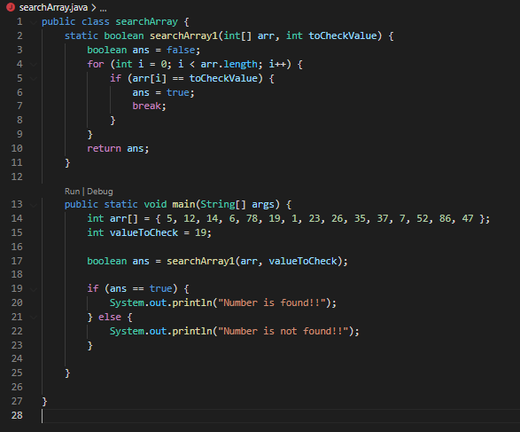



Q8. Using the below table write method apply sorting using Bubble Sort.

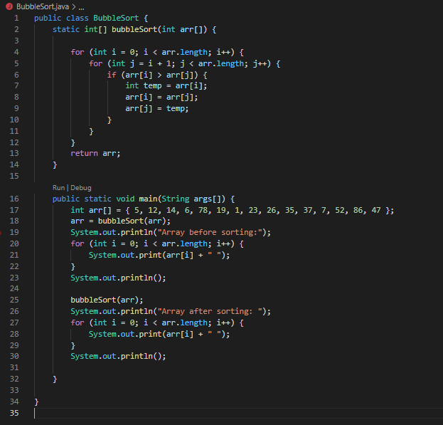

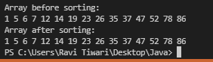

Q9. Accept the marks of three students for the subject say A, B, C. Find the total scored and the average in all the subjects. Also Find the Total and Average scored by students in each respective Subject.

